**GURU NANAK KHALSA COLLEGE**

**YAMUNANAGAR-135001**

**INTERNSHIP REPORT**

**ON**

**WEB DEVELOPMENT**

(SESSION: 2024-2025)



**UNDER GUIDENCE OF**

**Mrs. DOLLY ARORA**

**DEPTT. OF COMPUTER SCIENCE & APPLICATION**

**STUDENT NAME : Jangbhadur singh**

**UNIVERSITY ROLL NO. 2023203920**

1

**INDEX**

|  |  |  |
| --- | --- | --- |
| Sr. No | Section Title | Page No |
| 1. | Certificate | 1 |
| 2. | Acknowledgments | 2 |
| 3. | About the organization | 3 |
| 4. | Objectives of Internship | 4 |
| 5. | Details of Work done | 5-6 |
| 6. | Learning Experiences | 7 |
| 7. | Learning outcomes | 8 |
| 8. | Conclusion/Summary | 9 |

**CERTIFICATE**

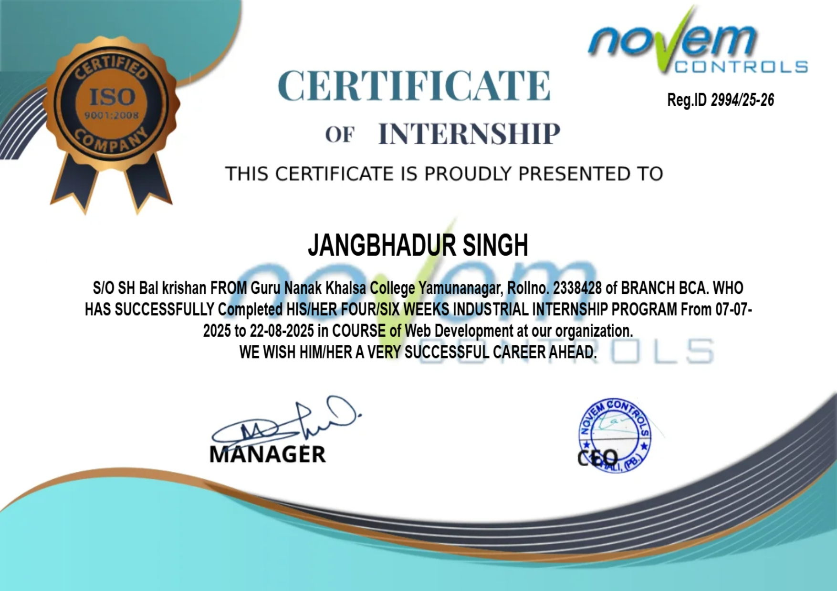

**ACKNOWLEDGMENT**

I would also like to extend my appreciation to Dr. Pratima Sharma, Principal, Guru Nanak Khalsa College, Yamuna Nagar for her continuous support and encouragement during my internship.

I would like to thank Mrs. Ishika Thakur for providing me with the opportunity to complete my internship at their organization.

I am incredibly grateful to my internship supervisor, Dr. Kiranpal Singh Virk and internship mentor Mrs. Dolly Arora, for their invaluable guidance and support throughout my internship. They provided me with clear direction and expectations, and were always available to answer my questions and provide valuable feedback. Their constructive feedback helped me to improve my skills and approach to my tasks, and their encouragement kept me motivated and focused.

**ABOUT THE ORGANISATION**

**Novem Control** is a technology-driven company located in **Phase 8B, Sector 74, Mohali**, specializing in **web development, software solutions, and digital services**. The organization is committed to delivering high-quality, innovative, and user-friendly digital products that cater to the unique needs of modern businesses.

The company’s core services include:

* Custom website design and development
* Responsive and mobile-friendly web applications
* E-commerce solutions
* UI/UX design
* SEO optimization and performance enhancement
* Integration of modern web technologies

Novem Control works with a variety of front-end and back-end technologies including **HTML5, CSS3, JavaScript, Bootstrap, PHP, Laravel, and MySQL**. It focuses on developing scalable and secure web solutions that help clients enhance their digital presence.

The company fosters a collaborative work environment where learning and innovation are encouraged. Interns and new developers are given opportunities to work on live projects and real-world client requirements, making it an ideal place for aspiring web developers to gain hands-on industry experience.

### **OBJECTIVE OF THE INTERNSHIP**

The primary objective of this internship was to **bridge the gap between academic learning and practical implementation** by gaining real-time experience in the field of Web Development. The internship was designed to help apply classroom knowledge in real-world scenarios and to understand how professional websites and web applications are planned, designed, developed, tested, and deployed. It also aimed to provide exposure to **modern tools, technologies, and industry practices** that are currently in demand.

Through this internship, I was able to strengthen my **technical expertise, problem-solving ability, and teamwork skills**, while also improving my professional approach to project handling and client-based development.

The primary objectives of the internship were centered around gaining both technical expertise and professional exposure in the field of web development. The internship aimed to provide a clear understanding of the complete end-to-end life cycle of web development, starting from requirement gathering and design to development, testing, deployment, and maintenance. It focused on enhancing technical proficiency in front-end technologies such as HTML5, CSS3, JavaScript, and frameworks like Bootstrap, with an emphasis on creating visually appealing and fully responsive designs. At the same time, the internship also concentrated on developing back-end skills by working with server-side scripting languages like PHP and integrating databases such as MySQL for efficient data storage and management.

Another key objective was to learn and implement responsive web design principles, ensure cross-browser compatibility, and follow UI/UX best practices to deliver smooth and accessible user experiences across different devices. The internship also aimed to strengthen debugging skills, analytical thinking, and code optimization techniques by engaging in practical problem-solving within real-world projects. Alongside the technical learning, it emphasized the use of version control tools like Git and platforms such as GitHub for efficient collaboration, version tracking, and professional project management.

Additionally, the internship provided valuable exposure to working on live projects under professional guidance, which helped in improving not only technical competencies but also essential workplace skills such as communication, collaboration, and time management. Finally, it also encouraged independent project development through mini-projects, enabling the application of creativity and logical thinking in implementing real-time solutions, thereby building confidence to handle projects individually in the future.

### **DETAILS OF WORK DONE**

During the course of my internship at **Novem Control**, I was actively involved in various tasks related to the design, development, and testing of websites. The internship provided me with practical exposure to a real-world development environment and allowed me to apply my theoretical knowledge of web development to live projects.

Below are the major tasks and responsibilities handled during the internship:

* **Website Design using HTML & CSS**:  
   Designed responsive web pages using HTML5 and CSS3. Learned to structure content using semantic HTML and style pages using modern CSS techniques including Flexbox and Grid.
* **Interactive Web Features using JavaScript**:  
   Implemented dynamic client-side behavior using JavaScript. Worked on form validation, DOM manipulation, and event handling to make pages interactive.
* **Responsive Design using Bootstrap**:  
   Created mobile-friendly layouts using Bootstrap classes and components. Ensured that websites function smoothly across different screen sizes and devices.
* **Version Control with Git and GitHub**:  
   Learned to use Git for version control. Regularly pushed code to GitHub repositories and collaborated on code reviews using pull requests.
* **Debugging and Browser Testing**:  
   Identified and fixed bugs using Chrome Developer Tools. Tested websites for compatibility across multiple browsers and devices.
* **Real-Time Project Exposure**:  
   Assisted in developing real-time client websites under the guidance of senior developers. Participated in internal team meetings and progress reviews.
* **Documentation and Code Structuring**:  
   Learned to write clean, maintainable code and follow standard naming conventions and folder structures.

**Internship Tasks and Responsibilities**

During the course of my internship, I was actively involved in various tasks related to the design, development, and testing of websites. The internship provided me with practical exposure to a real-world development environment and allowed me to apply my theoretical knowledge of web development to live projects.

Below are the major tasks and responsibilities handled during the internship:

**Website Design using HTML & CSS:**

* Designed responsive web pages using HTML5 and CSS3.
* Learned to structure content using semantic HTML and style pages using modern CSS techniques including Flexbox and Grid.

**Interactive Web Features using JavaScript:**

* Implemented dynamic client-side behavior using JavaScript.
* Worked on form validation, DOM manipulation, and event handling to make pages interactive.

**Responsive Design using Bootstrap:**

* Created mobile-friendly layouts using Bootstrap classes and components.
* Ensured that websites function smoothly across different screen sizes and devices.

**Version Control with Git and GitHub:**

* I learned to use Git for version control.
* Regularly pushed code to GitHub repositories and collaborated on code reviews using pull requests.

**Debugging and Browser Testing:**

* Identified and fixed bugs using Chrome Developer Tools.
* Tested websites for compatibility across multiple browsers and devices.

**Real-Time Project Exposure:**

* Assisted in developing real-time client websites under the guidance of senior developers.
* Participated in internal team meetings and progress reviews.

**Documentation and Code Structuring:**

* Learned to write clean, maintainable code and follow standard naming conventions and folder structures.

**Mini Project – Car Game Development:**

* As part of my internship learning, I developed a **Car Racing Game** using HTML, CSS, and JavaScript.
* Implemented features like moving objects, collision detection, scoring system, and increasing game difficulty with time.
* Focused on **DOM manipulation, animation techniques, and event handling** for smooth gameplay experience.
* Packaged the project into a **ZIP file** for submission and sharing, showcasing my ability to design, code, and deploy small-scale interactive projects independently.

**LEARNING EXPERIENCE**

My internship at **Novem Control** was a valuable and enriching experience that allowed me to apply theoretical knowledge in a practical, real-world setting. It significantly enhanced my understanding of the web development process and helped me develop both technical and soft skills that are essential for a career in the IT industry.

#### **🔹 Technical Skills Gained:**

* I learned how to **design and structure web pages** using HTML5 and style them using CSS3.
* I gained hands-on experience in making web pages **interactive using JavaScript**, including DOM manipulation and client-side validation.
* I explored **responsive design** techniques using **Bootstrap**, ensuring compatibility across different devices.
* I practiced using **Git and GitHub** for version control, which helped me understand team collaboration and code tracking.
* I improved my skills in **debugging**, testing websites on multiple browsers, and fixing layout or functionality issues.

#### **🔹 Real-World Exposure:**

* I worked on **live client websites** and understood how to meet client expectations, timelines, and functionality requirements.
* I experienced the **workflow of a professional development team**, including project planning, task assignment, daily updates, and code reviews.
* I learned how to handle feedback and make changes according to quality and user experience standards.

#### **🔹 Personal Development:**

* My **problem-solving** and **logical thinking** skills improved through coding challenges and debugging.
* I developed a better sense of **time management** by working with deadlines.
* My **communication** and **teamwork** skills strengthened as I interacted with developers and other interns.

**LEARNING OUTCOMES**

During my internship at Novem Control, I was able to translate classroom knowledge into real-world practice and strengthen my technical as well as professional skills. The internship gave me hands-on exposure to front-end web development and helped me understand how user interfaces are planned, designed, and implemented in a structured manner.

I gained confidence in working with HTML5, CSS3, and JavaScript, which enabled me to create structured layouts, responsive designs, and interactive elements. By developing a Car Game project, I learned how to combine these technologies to build a fully functional, interactive, and engaging application. Through this project, I worked on game logic, DOM manipulation, keyboard event handling, score tracking, and collision detection, which significantly improved my problem-solving and logical thinking skills.

Additionally, I became familiar with the process of debugging and testing web applications using browser developer tools. I learned how to identify errors in code, optimize performance, and ensure smooth functionality across different devices and screen sizes. The internship also helped me understand the importance of user interface (UI) and user experience (UX), where I focused on designing clean layouts and ensuring that the application was simple, intuitive, and enjoyable for users.

Some of the major outcomes of this internship include:

* Improved my ability to design responsive, interactive, and user-friendly web applications.
* Gained practical experience in JavaScript concepts such as events, animations, conditional logic, and real-time interactions.
* Learned to use DOM manipulation techniques for updating elements dynamically and controlling game flow.
* Understood how to debug, test, and optimize code efficiently.
* Enhanced my problem-solving, analytical thinking, and creativity through game development.
* Built confidence in handling an independent project from scratch, including design, coding, and testing phases.
* Strengthened essential professional skills like time management, communication, and self-discipline while working in a structured environment.

Through this internship, I developed a strong foundation in front-end development and gained the confidence to create interactive projects independently. The experience of working on a Car Game project not only refined my technical skills but also motivated me to explore more advanced concepts in web technologies and interactive applications.

**CONCLUSION**

My internship at **Novem Control, Phase 8B, Sector 74, Mohali**, has been an incredibly rewarding and insightful experience. It provided me with the opportunity to apply the concepts and skills learned during my academic coursework to real-life web development projects. I was able to enhance my technical knowledge, learn new tools and technologies, and gain valuable exposure to the workings of a professional development environment.

This internship not only helped me understand the complete website development process—from design to deployment—but also allowed me to improve my soft skills such as teamwork, time management, and communication. Working under the guidance of experienced professionals gave me the confidence to handle tasks independently and taught me the importance of writing clean, maintainable, and efficient code.